Location Recce
Please produce a location recce for EVERY location used
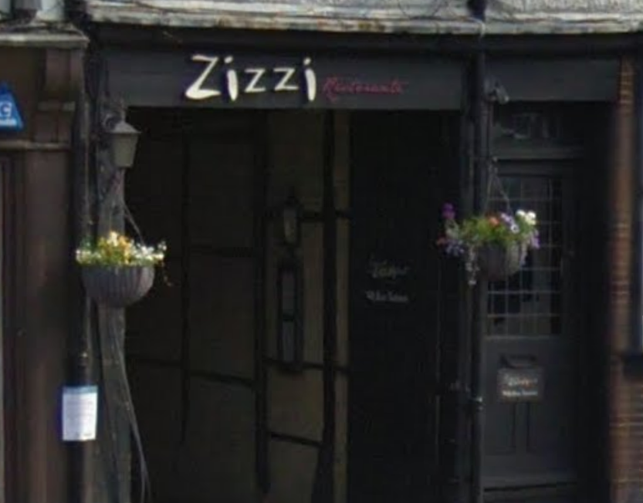
Type of room/area:
Corridor
Location Address:
21-23 Hart St, Henley-on-Thames
Sat Nav details (Post code):
RG9 2AR
Nearest Train Station:
Henley-on-Thames
Nearest Bus stop:
Hart Street

Lighting Information:  Very dark | Solutions:  Would require lighting
Sound Information:  Echoey, near a busy road | Solutions:  Would require overdubbing
Power Information  N/A | Solutions:
Hazards  Near busy road, cars going through | Solutions:  Film late when there are fewer cars

