Location Recce
Please produce a location recce for EVERY location used
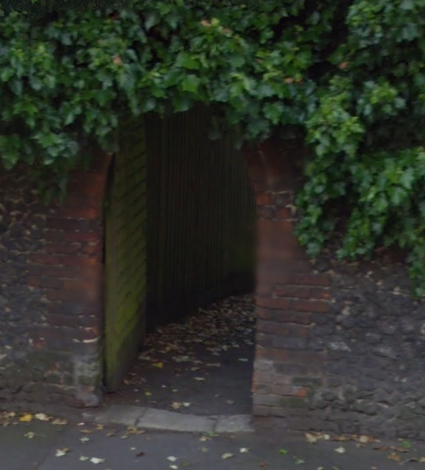
Type of room/area: Old door
Location Address:
Gravel Hill, Henley-on-Thames, England
Sat Nav details (Post code):
RG9 2EE
Nearest Train Station:
Henley-on-Thames
Nearest Bus stop:
Hart Street

Lighting Information:  Well-lit during the day | Solutions:
Sound Information:  Near a generator & busy road | Solutions:  Audio would have to be done in post
Power Information  N/A | Solutions:
Hazards  Busy road | Solutions:  Keep clear of the road

