Location Recce
Please produce a location recce for EVERY location used
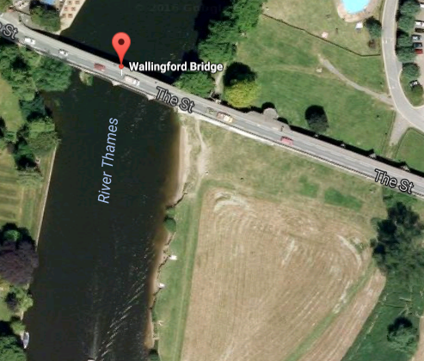
Type of room/area: Field near Wallingford Bridge
Location Address:
Wallingford
Sat Nav details (Post code):
OX10 0BJ
Nearest Train Station:
Cholsey
Nearest Bus stop:
Wallingford market square

Lighting Information:  Well lit during the day but no artificial light | Solutions:  Own lighting would need to be taken when there isn’t enough sunlight
Sound Information:  Fairly quiet, wind may be an issue | Solutions:  Boom mics
Power Information  N/A | Solutions:
Hazards  None | Solutions:

